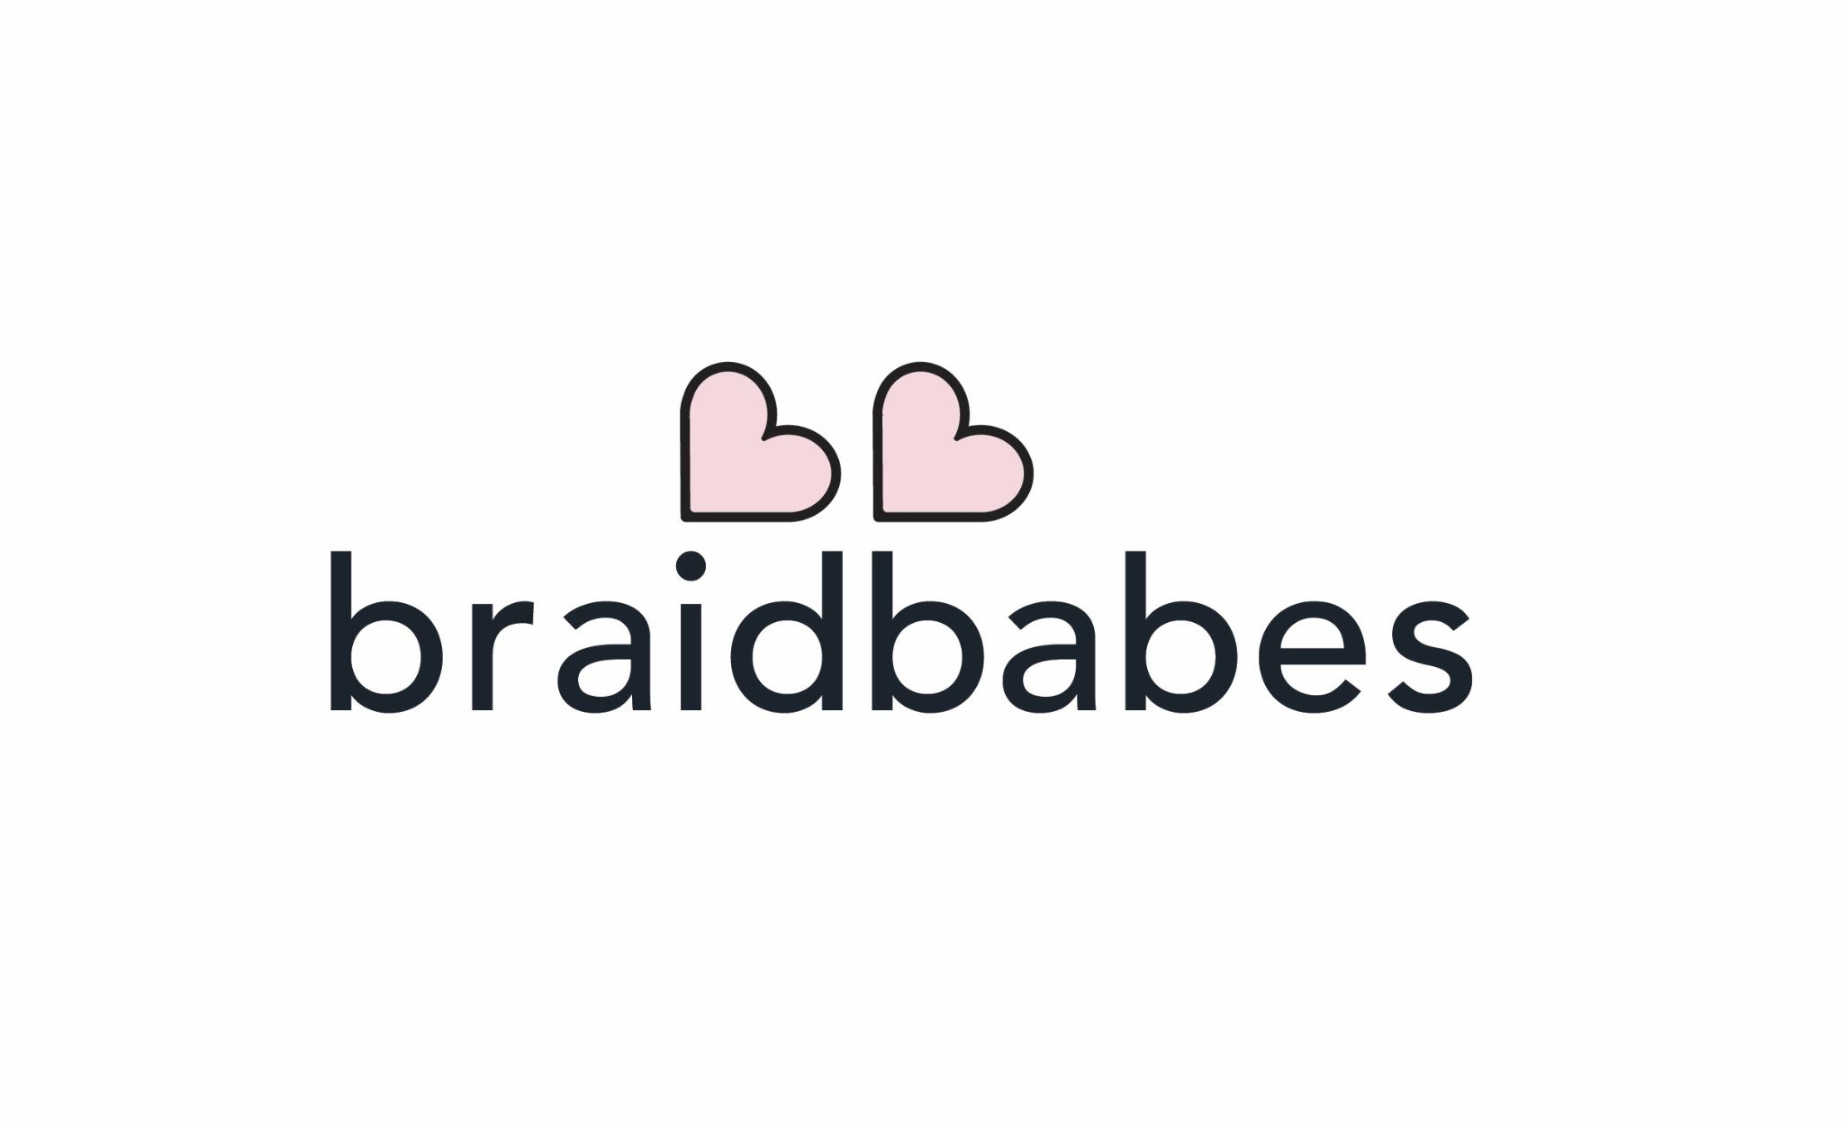
would you love to be a part of a fun & positive team environment? are you detail oriented with the ability to multitask? want to try the start-up life everyone is talking about? braidbabes is growing fast and we are looking for our next babe experience rep (ber) to join the braidbabes family. our ber’s are the heart and soul of our daily operations supporting our clients and our braiders equally.

applicant possess the following skills:
♡ detail oriented

♡ able to resolve issues (internally && externally)

♡ ability to multi task ( && keep a smile on)

♡ tech savvy - 90% of our work is done online and in apps

♡ able to work independently

♡ accountable (mistakes happen, let us know if issues arise)

♡ able to work efficiently in a fast paced && quickly changing environment

♡ able to maintain a positive attitude (you’re a babe after all!)

♡ reliable transportation (in person role, buffalo, ny)

♡ able to communicate in the voice of the brand

♡♡ BONUS : experience with logistics && event management, experience with booking systems

tasks will include:
♡ connecting with clients via email, phone && dm’s

♡ managing inbox for scheduling appointments

♡ giving the braidbabes customer experience to every client

♡ inventory management and supply fulfillment

♡ braider scheduling & logistics support

♡ keeping eyes out for new, more efficient solutions

♡ FT work - schedule that will include weekend days (on rotation, even start-ups need a saturday once in a while!)

please email your resume with a ‘cover email’ letting us know why you are interested in braidbabes to careers@braidbabes.com

